

Programme Name: _____BCS________________________________________________

Course Code: ___3432_______

Course Name: ___________Badminton_____________________________________

Assignment / Lab Sheet / Project / Case Study No/Proposal/Report____

Date of Submission: __________2020/07/17___________________

**Submitted By: Submitted To:**

Student Name: Dipesh Tha Shrestha Faculty Name: Manish Maharjan

IUKL ID: 041902900028 Department:PO

Semester: 2nd

Intake: September 2019

**TABLE OF CONTENTS**

**INTRODUCTION** 3

**VISION, MISSION AND OBJECTIVES** 3

**TYPE OF EVENT** 3

**BUDGET** 3

**RULES AND REGULATIONS OF THE EVENT** 3

**TENTATIVE EVENT** 4

**VENUE LAYOUT** 4

**CONCLUSION** 5

# **INTRODUCTIO**N

Badminton is a racquet sport played utilizing racquets to hit a shuttlecock over a net. In spite of the fact that it might be played with bigger groups, the most well-known types of the game are "singles" (with one player for each side) and "duplicates" (with two players for every side). Badminton is frequently played as an easygoing outside action in a yard or on a sea shore; formal games are played on a rectangular indoor court. Focuses are scored by hitting the shuttlecock with the racquet and landing it inside the rival side's portion of the court.

# **VISION, MISSION AND OBJECTIVES**

●The primary point of this Badminton Tournament is to advance games at Sunway College, by building great connection between the understudies and the staffs of Sunway College.

● We need to construct sportsmanship among the members, volunteers and staffs.

● The competition point is to diminish the two understudies and staffs for reward entertainment from work and study.

●We need to offer proceed to this game for long haul.

●To make protected, controlled and dependable amusement with a positive effect on understudy.

●To become a pioneer as far as nature of administration and amusement by creating ability and expert aptitudes.

# **TYPE OF EVENT**

The competition is an Intra-school Badminton competition. Understudies from all the semesters, both BCS and MBA, will be partaking in this occasion and College staffs will likewise be taking an interest in the competition which will be hung around the same time.

# **BUDGET**

The competition will be sorted out by the second semester of BCs supported by Sunway College and bolstered by Sunway IT and Youth Club and Event and Sport Club. The evaluated financial plan of the competition is NRS. 10000 - 11000. The financial plan comprehensive is for Ground charge, Referee charge, Reward, Equipment and some medical aid, .

|  |  |
| --- | --- |
| Particulars | cost |
| Reward (Trophy) | 7000 |
| Badminton Set | 4500 |
| First aid | 2500 |
| Energy Drink | 1250 |
| Fooding | 3000 |

# **RULES AND REGULATIONS OF THE EVENT**

The event is an Intra-college tournament so, only the students and staffs of Sunway College are eligible to participate in the tournament. The rules and regulations of the tournament are given below:

* A game can take place with single players.
* Player must come 20 minute before game start.
* There will be 20 players.
* Player must wear sport dress compulsory.
* You are required to win 21 points to win a set with most matches being best of 3 sets. Points can be won on either serve.
* An official match has to be played indoors on the proper court dimensions.
* To score a point the shuttlecock must hit within the parameters of the opponents court.

# **TENTATIVE EVENT**

The tournament will be held on June 2, 2019, at Sunway collage. Kickoff starts at 10AM.

|  |  |
| --- | --- |
|  | Time |
| Open ceremony | ( 11:00 – 10:00)am |
| Warm Up Session | (12:10-1:45)am |
| Game Start | (2:00-3:00)pm |
| Break | (3:00-4:00)pm |
| Game Start | (4:15-5:00)pm |
| Prize distribution | (5:15-6:00)pm |
| Closing ceremony | (6:00-6:30)pm |

# **VENUE LAYOUT**

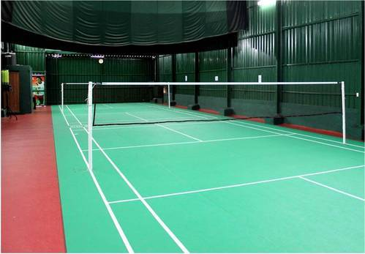

Figure 1 BADMINTON COURT

The field is made up of wooden artificial material, or similar surface, although any flat, smooth and non-abrasive material may be used. The **badminton court** is 13.4m long and 6.1m wide. For singles the **court** is marked 5.18m wide. The lines marking out the **court** are easily distinguishable and coloured white or yellow. The lines are 40mm wide.

# **CONCLUSION**

An Intra-college Badminton Tournament will be held on July 2th 2019, at Sunway collage sponsored by Sunway College and supported by Sunway IT and Youth Club.